27. Macroevolution *(RHM: Chapter 23)*

______________________________________________________________________________

I. Introduction: History of Life *(521-522)*

II. The Fossil Record *(522-527)*

A. How Fossils Form

1. sedimentation

-Fossils from in a variety of different ways:

-Liquefied minerals get into the wood and replace cell of the tree bit by bit

2. other mechanisms

B. What Fossils Can Tell Us

1. incompleteness of the fossil record

-Scavenges

-Sedimentation

-Subjected to geo forces, heat/pressure

2. relative and absolute time

-Fossils tell us when an organism lived

-Radiometric dating

3. ancient ecological communities

4. how characteristics changed through time

5. functional analyses of structures

III. Earth History *(527-530)* A. Introduction

B. Plate Tectonics

1. history of the idea

2. plate tectonics: the underlying mechanism

C. Continental Drift

1. patterns of continental movements

2. consequences of continental drift

IV. The History of Biodiversity (533-537)

A. Biodiversity

B. Adaptive Radiations

1 responses to ecological opportunities

2. examples of adaptive radiations

C. Extinction

1. background extinction rates

2. mass extinctions

D. Changes in Biodiversity Over Time

27-1

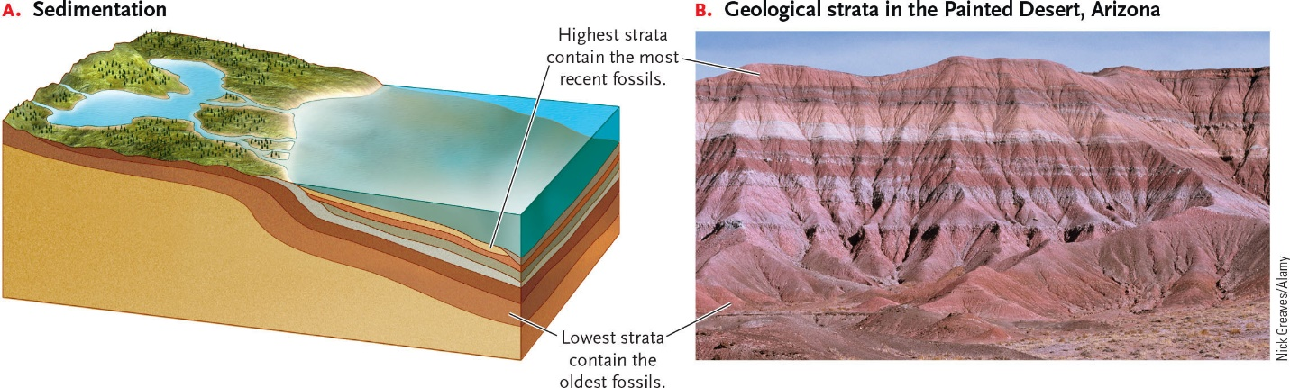

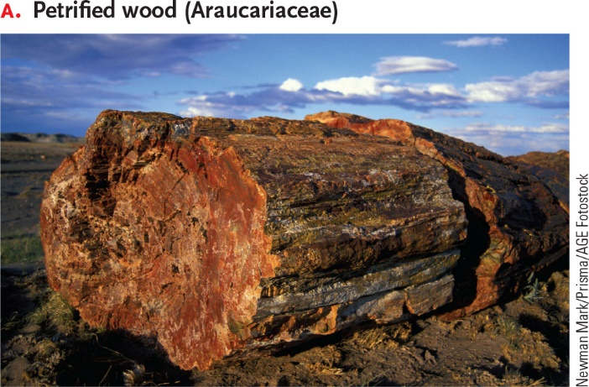 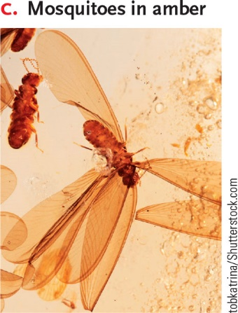

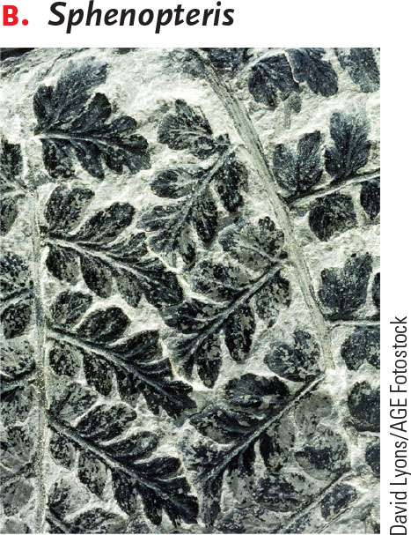 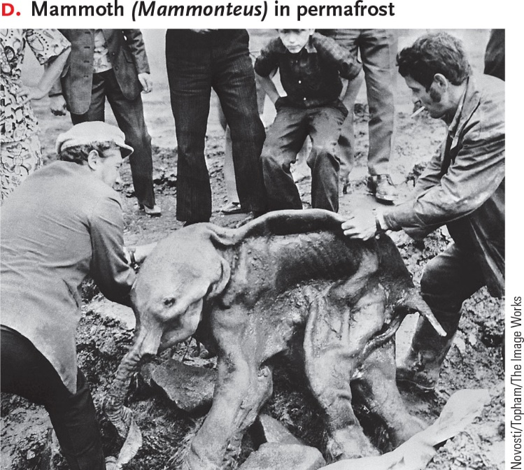

27-2

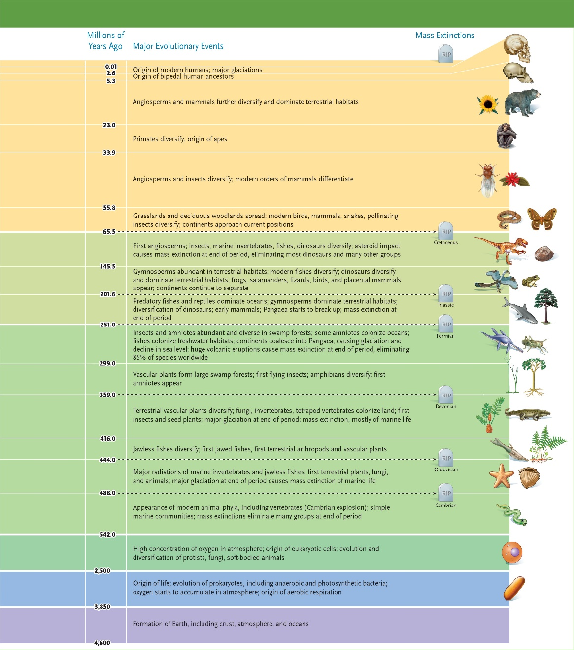

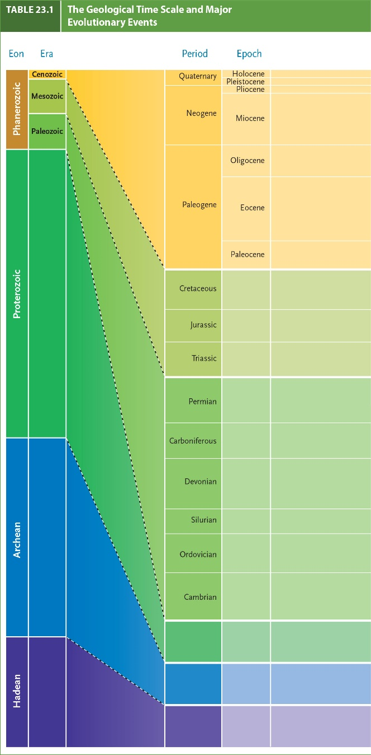

27-3

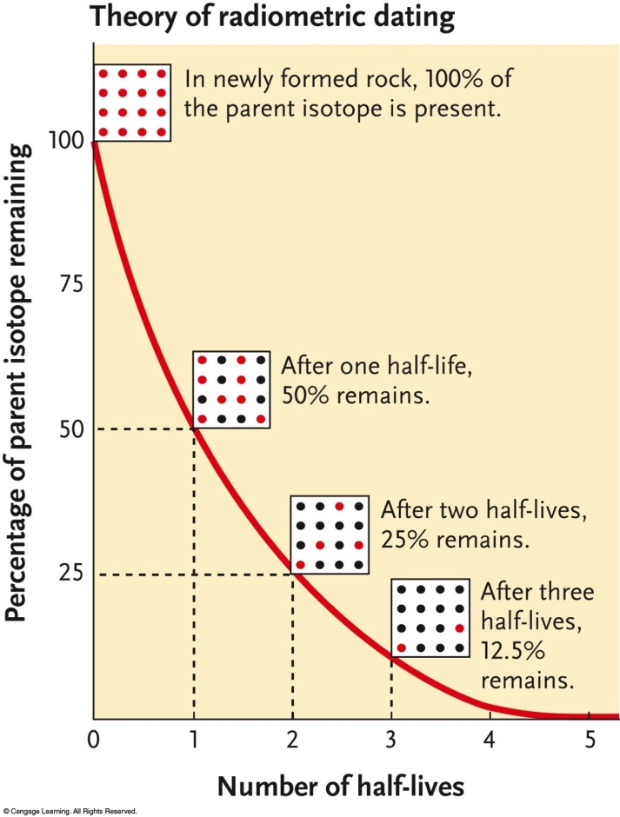

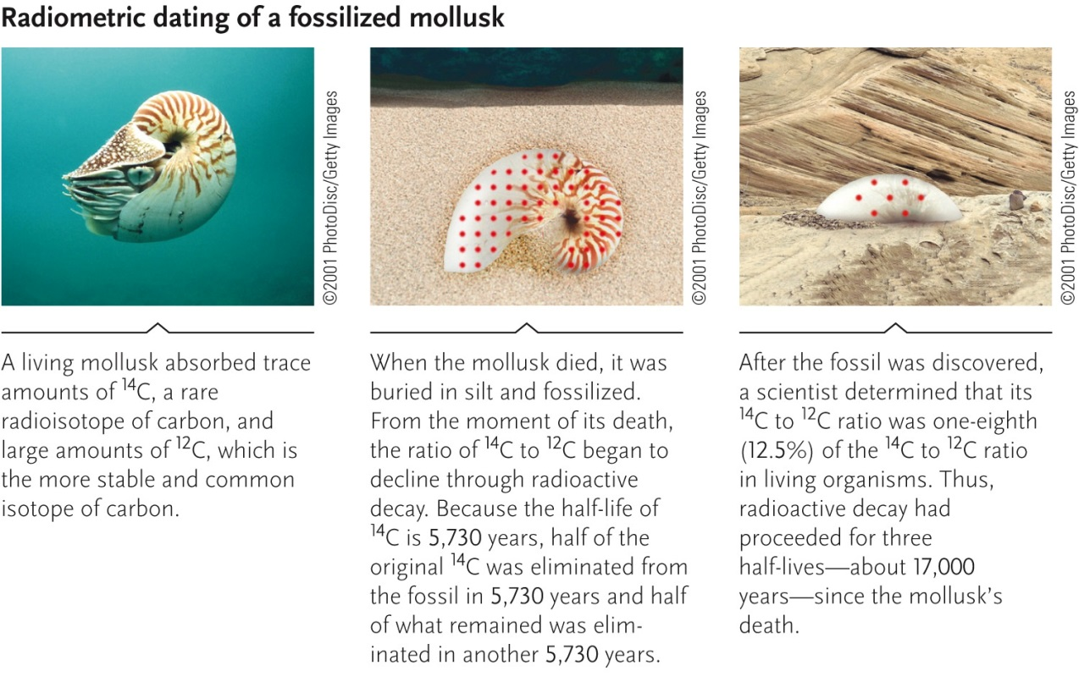

27-4

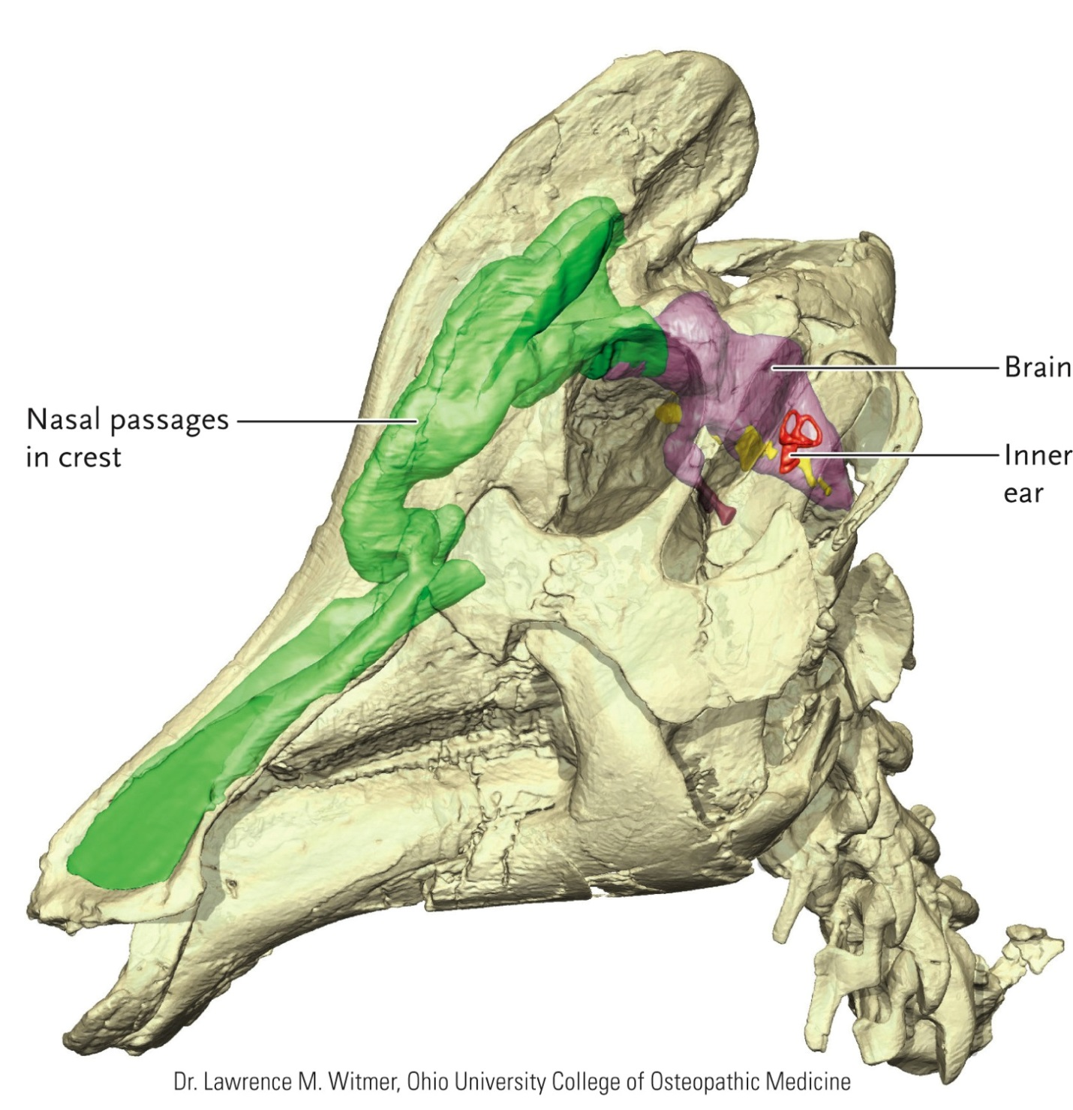

27-5

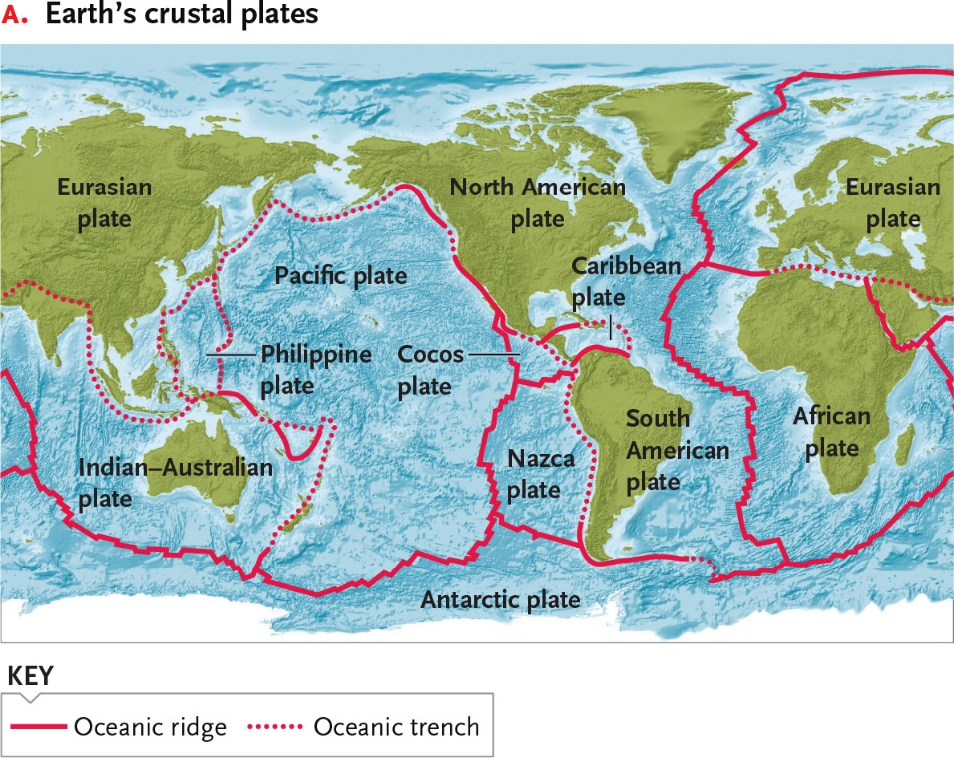

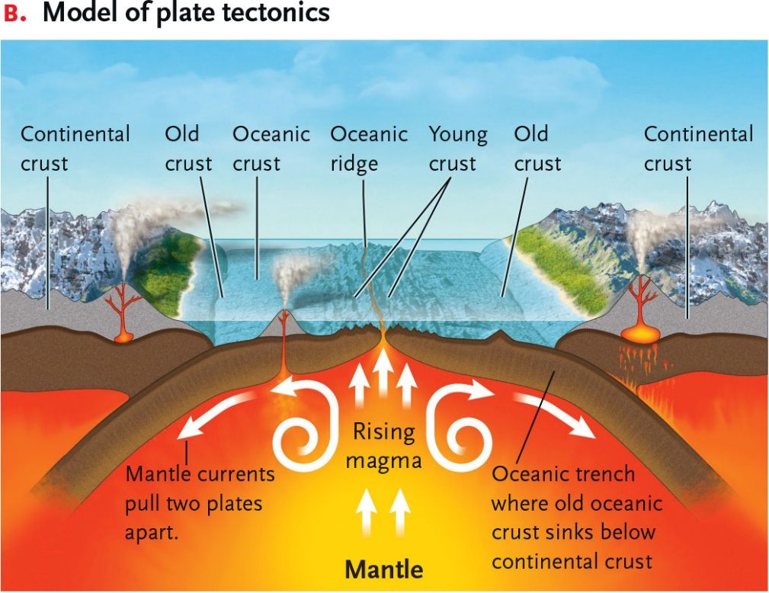

27-6

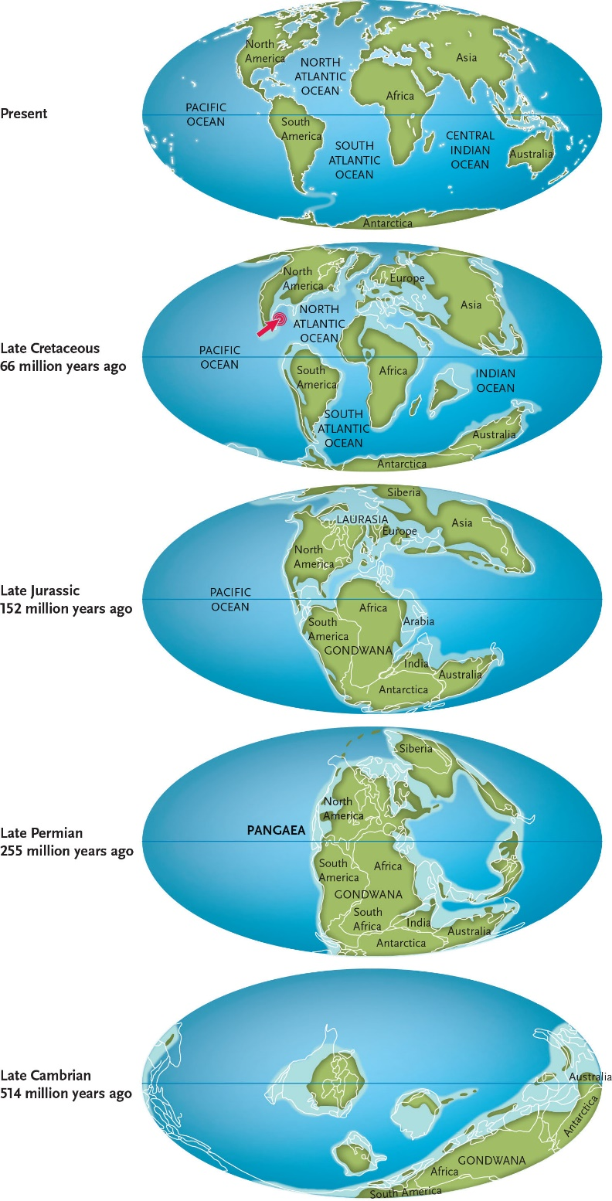

27-7

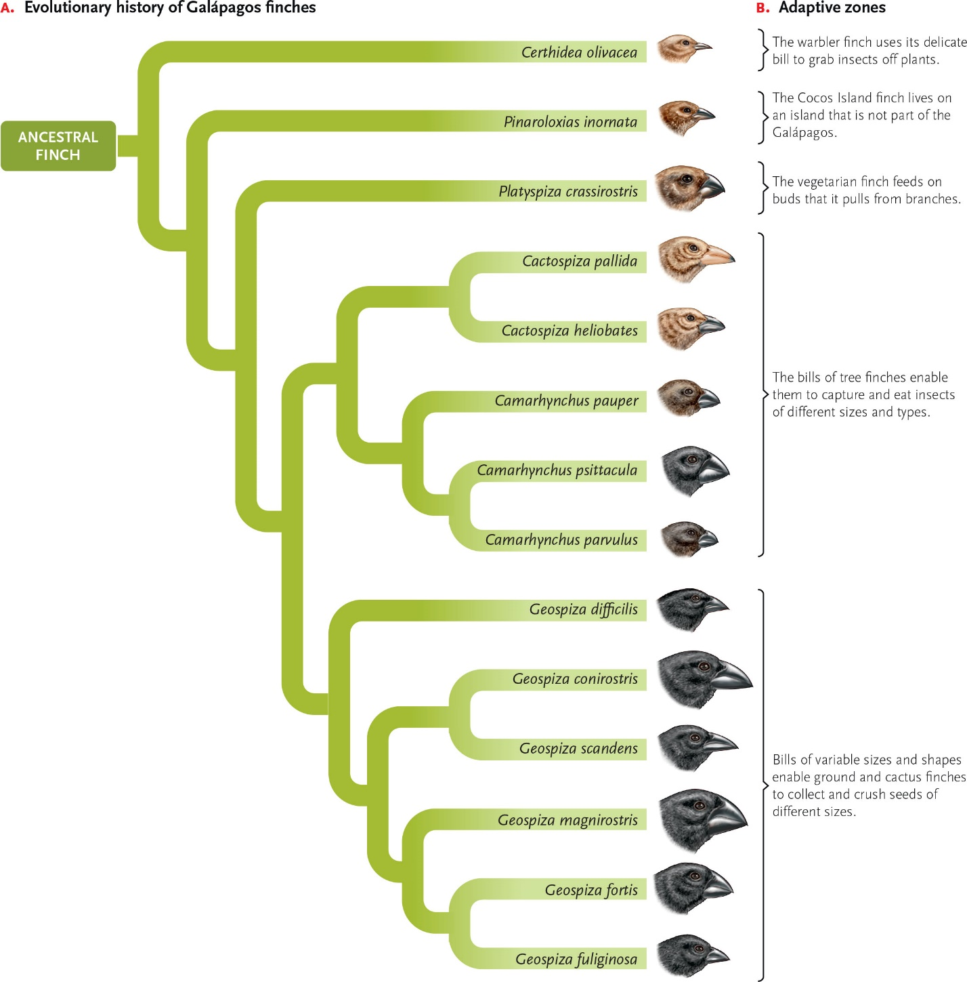

27-8

